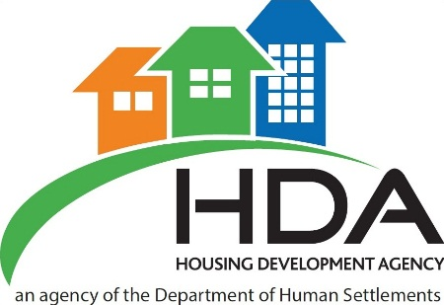

The Housing Development Agency (HDA) is a national public sector development agency that acquires and prepares land as well as develop the land and project manage the development of housing and human settlements. We carry out our activities in partnership with a range of stakeholders including national, provincial and local government and municipalities, as well as with communities, developers, financiers and other affected parties. Established in 2009, the Agency was established by an Act of Parliament in 2008 and is accountable through its Board to the Minister of Human Settlements. For more information about the HDA, please visit our website: www.thehda.co.za.

The HDA has the following three year fixed term contract position:

Project Manager: Gauteng
Location: Johannesburg
Reference: AP-PMG2018

Main Purpose: To manage all aspects of the Human Settlements Development projects of the HDA from inception up to close-out stage, that has been assigned and to ensure delivery on time, within budget and to required specifications and quality.

Key Responsibility Areas:

Project Planning:
- Prior to starting a project, conduct a comprehensive project planning process that includes delivery of:

- Project feasibility
- Project readiness
- Comprehensive scope
- Resourcing plans
- Budget projection and evaluation
- Project delivery deadlines
- Risk evaluation matrix
- Present completed documents that identify and highlight potential:
- Risks
- Opportunities
- Challenges
- Define and deliver:
- Project scope
- Detailed project plan with project timeframes and deliverables, and associated communication documents
- Project budget

Project Management:
- Secure appropriate resources of housing and related services to achieve project objectives
- Manage resources to deliver according to defined outputs and project plan deliverables
- Manage all site based meetings
- Develop service level agreements and contracts (including standard professional contracts) for resources on the projects, specifically the professional teams and sub-contractors
- Monitor and manage the performance of professional teams and sub-contractors to ensure delivery as stated in the project plan.
- Management of housing and related services project budget
- Management of relationships with key stakeholders and community representatives
- Controlling and coordinating the projects:
- Scope
- Time
- Quality
- Budget
- Integration
- Human Resource Management
- Communication
- Risk and
- Procurement Management
- Proactively manage changes in project scope, identify potential crises and devise contingency plans
- Develop and implement risk management plans and strategies for housing and related services projects
- Complete and present post implementation review to senior management and project teams to identify successes, challenges and lessons from the project.
- Develop best practices and tools for project execution and management

Project Administration:
- Contribute to project related procurement including
- Drafting terms of reference
- Providing input into procurement proposals
- Develop funding proposals
- Drafting, submission and presentation of housing and services project related management reports

Quality:
- Ensure adherence to quality in the delivery of housing infrastructure
- Develop and implement site inspection processes
- Ensure compliance with legal, contractual and safety requirements
- Ensure that onsite occupational Health and Safety requirements are met and complied with

People Management:
- Select, assign, lead and manage people
- Set clear objectives for self and others and measure achievements against these objectives through implementation of the performance management system
- Build and manage relationships with staff members
- Manage and support staff development
- Develop and manage the implementation of succession plans for key individuals and critical positions
- Implement the HDA HR policies and procedures as required
- Manage risks and address issues as they arise

Compliance Management:
- Manage implementation of work within established policies, systems, procedures, processes and practices
- Provide advice and assistance to others in order to ensure their compliance with policy and governance procedures
- Identify areas of non-compliance and implement corrective action

Requirements:
- A relevant degree or equivalent qualification in the built environment (Civil Engineering, Construction Management, Quantity Surveying, etc.) is required
- Relevant project management qualification (NQF 5 or 6)
- Registration as a Construction Project Manager or other recognized equivalent professional accreditation will be a recommendation.
- Computer literacy including Microsoft Projects packages
- 5 years’ experience as a construction project manager
- Experience in housing construction and/or infrastructure based project management is required
- Experience in the delivery and project management of affordable housing projects & infrastructure is preferable
- Drivers License and own car

Please forward relevant CV (Clearly marked with the reference number of the position).in a Microsoft Word format to applicationsjhb@affirm.co.za

Should you not comply with the above requirements your application will NOT be considered.

Closing date for applications: 2 June 2018

CVs received after the closing date will NOT be considered. Kindly take note if you have not been contacted within fourteen (14) days of the closing date; please consider your application unsuccessful.

Enquiries: Sacha Meyerson (011) 883-5035

--------------------------------------------------------------------------------------------------------------------------------------
Conditions of service: The HDA is an equal opportunity employer ● Appointments will be made in accordance with the HDA Employment Equity policy ● The HDA reserves the right not to make an appointment.

Please do not send certificates, diplomas or testimonials. We thank all applicants for their interest. Communication will be conducted with short-listed applicants only.

